S.S.G. AUCTION 74
Autumn 2024

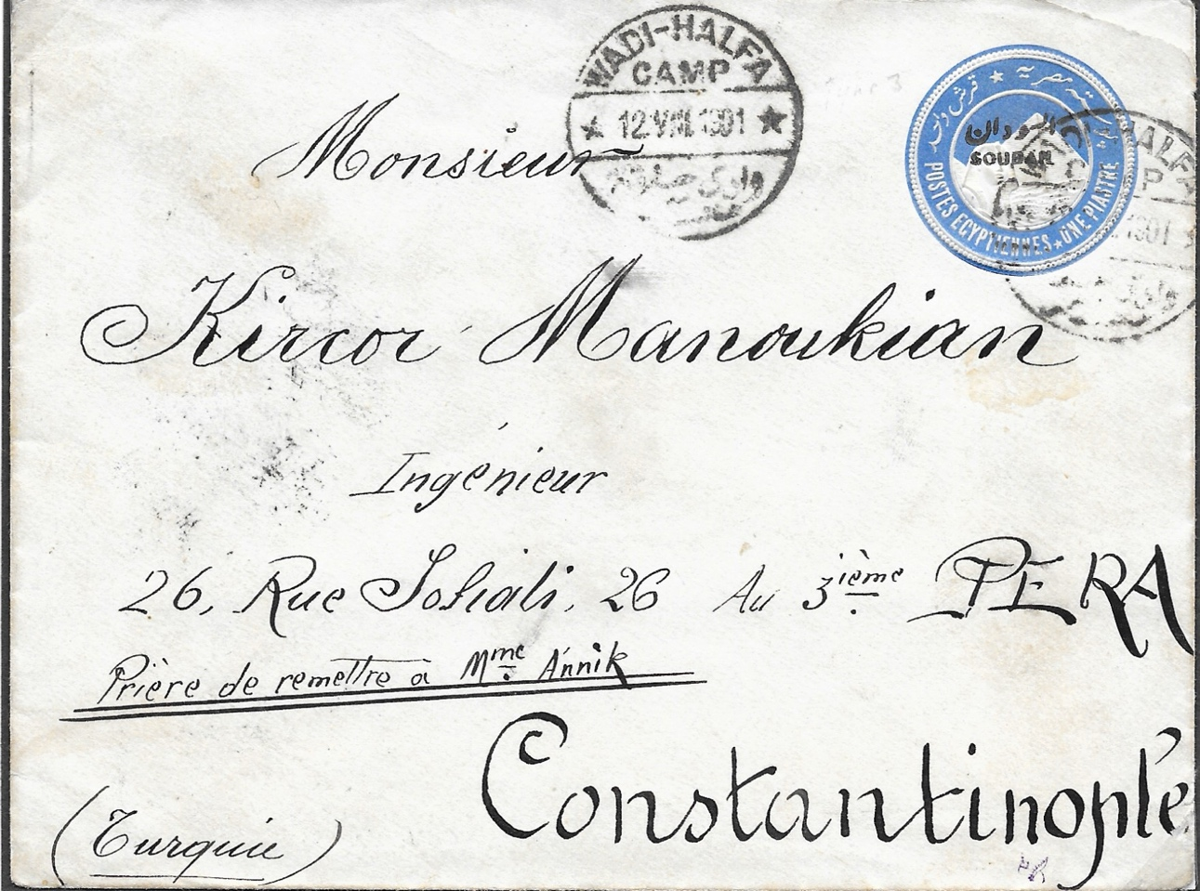

51

Closing Date for Bids:

Thursday 31 October 2024

Email: ssgauction@gmail.com

Post: Jacke Phillips
5 Romsey Mews
Cambridge CB1 3PB UK

SSG Auction Catalogue 74

No. | Date | Description | Reserve
1 | 1902-21 | Star and crescent 1902 issue including: 2mm SG19 (c. x80); 3mm SG20 (c. x45); 5mm SG23 (c.x170); and 1pt SG24 (c. x45). Stamp packets sorted by value, generally all used, ideal for sorting shades, minor varieties, etc. | £5.00
2 | 1940 | 5mm on 10mm small camel SG78 (c. x127) used incl. several blocks and pairs etc., Cat. £1.75 each, so total c. £222. Stamp packets sorted by value, generally all used, ideal for sorting shades, minor varieties, etc. | £15.00
3 | 1936-55 | Packets of old Arabic small camels SG overprint on SG watermarked paper including: 2mm on chalk surfaced paper SG O33a (x10) Cat. £70 each (one stamp has top left corner perf missing); 3mm SG O34 (x50); 15mm SG O38 (x35); 5mm SG O36 (singles x7 and pairs x2); 5mm SG O36a (singles x20, pairs x8, and blks of 4 x2); 10mm SG O37 (singles x140, pairs x4, and blks x2). Stamp packets sorted by value, generally all used, ideal for sorting shades, minor varieties, etc. | £30.00
4 | 1906-48 | A mixed selection including: 5mm large camel SG O15 punctured S.G. (near x80); 5mm Army Service SG A9 used (x20); 3p o/p SG, SG O39b used (x25) Cat. £2.75 each; 4p o/p SG, SG O39ca used (x5), Cat.£4.50 each; 5p o/p SG, SG O40a used (x20) Cat £5.50 each; and 6p o/p SG, SG O40b used (x10) Cat. £10 each. Also 15mm new Arabic officials SG O49 used (c. x5). Stamp packets sorted by value, generally all used, ideal for sorting shades, minor varieties, etc. | £20.00
5 | 1927-45, 1948 | Another mixed selection including small camels SG38-43 (x120), 5p large camels SG45 (c. x60); SG45 (a few); SG99 4mm small camel (x50+, many in blocks and pairs), Cat. £2.75 each; as well as a few pictorial air mails. Stamp packets sorted by value, generally all used, ideal for sorting shades, minor varieties, etc. | £7.00
6 | 1935, 1948, 1954 | Large commemoratives SG112, 113, 114,140-42 (100’s), Gordon 5mm value SG59 (100+), as well as a packet of later used commems. Stamp packets sorted by value, generally all used, ideal for sorting shades, minor varieties, etc. A ‘happy hunting’ bargain! | £5.00
7 | 1951 | 5, 10 and 15mm, both ordinary and SG overprinted used, in large quantities. Rather than throw them away someone may like to trawl through them in the hope of discovering the odd shade, variety, paper variation, etc. In addition, SG O74 or O74b, O76 or O76a, O77 or O77a, and O78, many with readable postmarks, English or Arabic or both many with dates, a few of which might be uncommon. | £5.00
8 | 1951,  1962 | A similar lot but based on the 1962 issue, with SG128, 129, O71, O72, and O74 used, in large quantities. In addition, 1951 SG O74 or O74b, SG O75 or O75a, and O78, many with readable postmarks, English or Arabic or both, many with dates, a few of which might be uncommon. Also, SG181 10pt sailboat including some perforation variants (c. x200). | £5.00
9 | 1935-80 | Selection of 33 mixed covers (see scan), including mint 4pt air letter (wild game, AL9) and an unused FDC intended for the 1963 Red Cross centenary set. | £5.00
10 | 1906 | Sepia PPC featuring Miss Evie Greene (Edith Elizabeth "Evie" Greene was a much-photographed English actress and singer who played in Edwardian musical comedies in London and on Broadway) from Brighton to Sawakin where it arrived 22 AV 06. | £3.00
11 | 1910 | Cover from UK to Capt. Snow in Port Sudan but readdressed to ‘Khtm’ where it arrived 10 OC 10 (Stagg type 41). Well-worn but interesting. | £3.00
12 | 1956-1980’s | Collection of covers, first day, commemorative and definitive, some addressed, some commercial, some unaddressed. See photos. A few nicer postmarks among these besides the usual Khartoum incl: Khartoum South, Omdurman, El Obeid, Philatelic Section, New Halfa, Yei, Wadi Halfa, Bor, Rufaa, Khartoum Air Port, Kassala Registered, Wad Medani, Ferreig. Some covers with post-paid marks. Noted that some post-paid marks also used for cancelling stamps.110+items. Unpacked album weight 1.4kg. | £15.00
13 | 1936 | SG O34, block of 18 (3 x 6), mostly mnh, have marks on reverse of 2 as shown, Cat £90. | £10.00
14 | 1936 | SG O41a, corner block of 4 with plate number, stamps mnh but hinge remains on selvedge, Cat £240. | £25.00
15 | 1903-1912 | SG O4, 2 corner block of 4 with plate number, stamps mnh but hinge remains on selvedge, Cat £152. | £15.00
16 | 1913 | SG O20, 10 piastre Official stamp, used, in fine condition, Cat £50. | £5.00
17 | 1948 | Postage Due Block of 6 (SG D13), mnh, Cat £66 | £5.00
18 | 1984-1991 | Commemorative issues betw. SG402 and SG509 incl.: 1984 Economic Commission; 1984 Shaykan battle; 1984 Olympic Games; 1985 Sudan-Egypt Treaty; 1985 Teacher Training; 1986 April Rising; 1988 Child Health min sheet MS430; 1988 Red Crescent; 1988 Bank of Khartoum; 1988 World Food Day; 1989 Palestine Freedom; 1989 Intifada; 1989 Development Bank 200pt slightly foxed; 1990 Animals slight foxing and ex 75p; 1991 National Salvation ex 10LS; 1991 Rinderpest. Generally all umm, many with selvedge. STC £76+. | £15.00
19 | 2006-2008 | Commemorative issues betw. SG665 and SG691 incl: 2006 50th Anniv. Independence; 2007 Africa Football Union; 2007 UPU Congress; 2007 Rascom; 2008 National Census; 2008 Peace Agreement. All umm, many with selvedge. STC £140. | £30.00
20 | 1897 | 1m-10pt SG1-9 fine used, Cat £110. | £35.00
21 | 1897 | 10pt SG9 fine used, Cat £70. | £20.00
22 | 1897 | Postage dues 2m – 2pt (2m,4m,1pt on piece) (SG D1-D4), all cancelled ‘Khartoum 10.9.98,’ the day the post office opened. | £12.00
23 | 1897 | Overprinted postage dues 2m, 4m, 1pt & 2pt (SG D1- D4) in vfu blocks of 4, Cat £60. | £16.00
24 | 1946 | Block of 4 1m camel stamps overprinted ‘SG’ (SG 032,) used, Cat £80. | £15.00
25 | 1946 | 8pt camel stamp overprinted ‘SG’, SG O40c, used, Cat £45. | £10.00
26 | 1937 | 10pt camel stamp overprinted ‘SG’ on chalk-surfaced paper (SG O41), mm, Cat £65. | £16.00
27 | 1937 | 10pt camel stamp overprinted ‘SG’ on chalk-surfaced paper (SG O41), used, Cat £30. | £8.00
28 | 1941 | 10pt camel stamp overprinted ‘SG’ on ordinary paper (SG O41a), used, Cat £15. | £4.00
29 | 1946 | 20pt camel stamp overprinted ‘SG’ (SG O42), fine used, Cat £35. | £9.00
30 | 1946 | 20pt camel stamp overprinted ‘SG’ on ordinary paper SG O42 umm block of 4, Cat £180. | £40.00
31 | 1948 | 5th Camel issue overprinted ‘SG’, 1m-15m in upper left plate blocks of 6 with ‘nun’ flaw on 1m, 3m, 5m,10m, 15m (row 2/3) umm but gum disturbance on 4m block, Cat £215. | £50.00
32 | 1950 | Airmail set of 8 Official stamps overprinted ‘S.G.’ in umm upper corner blocks of 4, Cat £140. Superb. | £36.00
33 | 1951 | ‘Shaduf’ Essays, black and red imperf block of 4 plate proofs. The essays were not approved. | £15.00
34 | 1951 | Pictorial set (17) 1m – 50pt, umm, Cat £120. | £28.00
35 | 1951 | Pictorial Issue, 1m, 2m, 4m-10m, 2pt -50pt in umm blocks of 6 (no 3m & 15m) (SG123, 124, 126, 127a, 128, 130a, 131a, 132a, 133a, 134, 135a, 136a, 137, 138, 139). The ‘a’ nos. are all better shades, Cat £700+. | £100.00
36 | 1975 | 10 L.S. sailing boat no watermark (SG 199), umm, Cat £50. | £12.00
37 | 1979 | 10m & 20m postage dues on Sudan Arms (Rhino) watermark paper, umm. | £12.00
38 | 1990 | £1 handstamped surcharge on 10pt sailing boat perf 14½x14 (SG 468a), umm, Cat £140. | £36.00
39 | 1991 | Official 10 L.S. sailing boat (SG O227), umm, Cat £32. | £10.00
40 | 1905 | 1m Army Official stamp block of 4 with variety ‘!’ for ‘I’ in ‘Official’ in lower left stamp (SG A1a), mm, total Cat £120. | £40.00
41 | 1905 | 1m Army Official pair with large & small overprint se-tenant SG A1c, hinged mint, Cat £130. | £35.00
42 | 1905 | 1m Army Official stamp with ‘Army’ reading down, lmm, SG A3, Cat £200. | £55.00
43 | 1913 | 2pt stamp overprinted ‘Army Service’ (SG A11), cancelled Taufikia 15.V.911, fu, Cat £15. | £4.00
44 | 1913 | 5pt stamp overprinted ‘Army Service’ (SG A12), cancelled Taufikia 10.V111.911, Cat £70. | £16.00
45 | 1913 | 3m Army Service stamp punctured ‘A.S.’ (SG19), lmm, Cat £75. | £20.00
46 | 1913 | Army Service 5pt stamp punctured ‘AS’ (SG A24), gum slightly toned, umm, Cat £120. | £35.00
47 | 1898 | Postal stationery envelope type EN3 with type II overprint to Cairo cancelled Kerma 21 II 98 (Stagg type 29). On reverse Halfa transit mark 23 II 98. A fine cover. | £110.00
48 | 1898 | Postal stationery envelope type EN3 with type V overprint to Cairo cancelled Berber 22 MR 98 (Stagg type 29). On reverse Halfa transit mark 2 IV 98, env. flap stuck down & sealed with stamp edging! | £50.00
49 | 1898 | Postal stationery envelope type EN3 with type V overprint cancelled Merowi 15 V111 98 T1 (Stagg type 29). A fine cover addressed to Captain Brooks, Army Servicer Corps, Alexandria. | £95.00
50 | 1899 | Postal stationery envelope type EN3 with type B-1 overprint to Cairo cancelled Omdurman 7 111 99 (Stagg type 24). | £50.00
51 | 1901 | Postal stationery envelope type EN4 with type D overprint to Constantinople cancelled Wadi Halfa Camp 12 V111 1901 (Stagg type 25). | £50.00
52 | 1929 | Flown cover to England franked 23m endorsed ‘By Air Mail’ with Air Mail label & cancelled Khartoum 8 DEC 29. On reverse Caire 12 DE 29 transit mark. | £5.00
53 | 1930 | Cover to England franked 10m camel stamp cancelled KHARTOUM TRANSIT 14 OCT 30 (SSG type S16-3, Stagg 63). | £6.00
54 | 1931 | Imperial Airways cover to England franked 3pt cancelled ‘Sudan Air Mail Khartoum 11.111.31, ‘Khartoum to London’ First Flight cachet and ½d receipt surcharge on arrival. | £9.00
55 | 1931 | Air Mail card to Germany with a Zeppelin illustration, franked 2½pt on 2pt Air Mail stamp SG58, cancelled Sudan Air Mail Khartoum 5.1X.32. | £9.00
56 | 1933 | Flown cover to London franked 5pt Gordon Statue stamp cancelled Port Sudan Quays 19 MR 33, Sudan Air Mail Atbara 19 MR 33 transit mark. | £8.00
57 | 1939 | Advice of delivery card franked 10m camel stamp cancelled by part boxed ‘AR’ mark, Khartoum registered datestamp 13 KJU 39 & on reverse Atbara cds 15 Jun 1939. 2 filing punctures at left. | £20.00
58 | 1950 | Postcard depicting the Blue Nile at Khartoum, no. 755 published by Tropical Photo Stores, Khartoum. | £3.00
59 | 1988 | Flown cover franked 2 x 10pt 1951 stamps with black ‘S.G.’ overprint (SG O81a) & 1962 55m all cancelled Kosti W.N. Mails -6 JUN 1988. | £3.00
60 | 1906 | Official 10pt overprinted O.S.G.S. (SG O4) cat £25 mm | £6.00
61 | 1900 | cover to UK, 1p (SG14) tied Omdurman 31 V 00 TV1 (x2) (Stagg 32 previosly unlisted for this office). Backstamped BENI SOEUF-CAIRE AMB3 and MALVERN. | £16.00
62 | 1951 | 1m to 50p set (SG123-139) (17) umm. Cat £100. | £30.00
63 | 1948 | 1m to 50p set (SG96-111) (16) umm. Cat £75. | £20.00
64 | 1951 | 1m to 50p set (SG123-139) (17) umm. Cat £100. | £30.00
65 | 1927-1941 | 15m (SG43) mm with vignette shift 2mm downwards. | £15.00
66 | 1990 | large registered Arabic cover to Cairo; strip of 8 x 150p (SG439) tied with feint KHARTOUM cds x 4. Backstamped KHARTOUM 20 DEC 1990 (Stagg 60) and CAIRO. Very attractive. | £7.00
67 | 1962 | definitives 10m to £S1 (SG171-184) fu. Cat £10+. | £4.00
68 | 1927 | 4m (SG40aw) INVERTED WATERMARK gu. Cat £75. | £15.00
69 | 1931 | Air 15m to 10p (SG52a - 57d) (12) lmm. Cat £33. | £10.00
70 | 1950 | Air set (SG115-122) umm LH marginal copies. Cat £22. | £7.00
71 | 1950 | Air set (SG115-122) on official FDC with KHARTOUM 1 JUL 50 cds (Stagg 46). | £6.00
72 | 1946 | incoming plain FDC cover from USA to Khartoum, WASHINGTON 30 JAN 1946 on 4x 5c Freedom of Speech and Religion stamps. Backstamped ALEXANDRIA 27 FE 46 and SHELLAL HALFA 4 MR 46 (Stagg 213). | £3.00
73 | 1960 | Arab League (SG152) FDC on plain typed address envelope, KHARTOUM SOUTH 22 MAR 1960 cds (Stagg 112-4). Backstamped as front. | £5.00
74 | 1948 | 4½p registered postal stationery envelope (RE12) mint. | £5.00
75 | 1897 | 3m purple postal stationery card (PC1) o'pt type A1. Mint. | £6.00
76 | 1897 | 3m purple postal stationery card (PC1a) o'pt type II. Mint. | £6.00
77 | 1914 | 3m Small Camel postal stationery card, reddish lilac (PC18), mint | £5.00
78 | 1969 | 4p Sudan Game air letter (AL9) uprated with 10m Cotton Picker; 2 CTO covers KHARTOUM 24 DEC 69 cds and PHILATELIC OFFICE KHARTOUM 20 05 1969. | £6.00
79 | 1960 | 4p Weaver air letter (AL8) x2; 1) mint. 2) to USA KHARTOUM 29 MAR 1961 cds (Stagg 46). | ££5.00
80 | 1960 | 4p Weaver air letter (AL8) mint. | £4.00
81 | 1960 | 8p Palm Trees air letter (AL10) with SG180 imprint in green; PHILATELIC SECTION KHARTOUM 16 MAR 1974 cds | £5.00
82 | 1960 | 8p Palm Trees air letter (AL10) with SG180 imprint in green. Mint. | £6.00
83 | 1960 | 60 8p Palm Trees air letter (AL10) with SG180 imprint in deep green with no background. Mint. | £8.00
84 | 1972 | 8p Palm Trees air letter (AL10) with SG180 imprint in light green to London; 2x indistinct JUBA MAILS cds (Stagg 71-7), | £6.00
85 | 1952 | 2½p Kassala Jebel air letter (AL6), mint. | £4.00
86 | 1952 | 2½p Kassala Jebel air letter (AL6) x5; used with different postmarks, some uprated. | £10.00
87 | 1974 | East African lithographed stampless air letter with illustration of a young vervet monkey at lower left to England; JUBA 5 NOV 1974 cds (Stagg 71) on SG348. Front only. | £5.00
88 | 1968 | stampless air letter to England with 4p Sudan Game definitive tied with OMDURMAN MAILS 15 JAN 1968 (Stagg 71). Fighting zebras illustration at bottom LH corner. | £5.00
89 | 1970 | stampless air letter to England with 10m Cotton Picker definitive and 4p ILO stamps tied with KHARTOUM MAILS 17 FRB 1970 cds (Stagg 71). | £5.00
90 | 1962 | 4p Sudan Game air letter (AL9) light shade. Mint. | £4.00
91 | 1950 | Official air set (SG O59-66) lmm. | £10.00
92 | 1948 | 1m to 20p Officials (SG O43-O58) mm. Cat £75. | £20.00
93 | 1951 | Printers trial of 5m Shilluk Warrior on coarse pink paper with SG overprint right way and reversed. | £10.00
94 | 1948 | 1m to 50p SG o'pt set (SG O43-O58) umm. Cat £75. | £30.00
95 | 1948 | 1m to 20p Officials (SG O43-O58) fu. Cat £80. | £15.00
96 | 1951 | 1m to 50p set (SG O67-O83) fu. | £10.00
97 | 1954 | OSGS official cover addressed in Arabic. OMDURMAN registration label and OMDURMAN 25 JAN 54 cds (Stagg140). Backstamped as front plus pt KHARTOUM. | £8.00
98 | 1951-1952 | OSGS covers x2. P&T no 17 1952 cover to Khartoum MALAKAL 3 II 53 (Stagg 61) backstamped KHARTOUM 3 II 53 (Stagg62). P&T no 17 1951 KHARTOUM 16 JAN 1954 (Stagg 87-1). | £5.00
99 | 1953 | OSGS cover (P&T no 16) air mail to New York; KHARTOUM 1 MAY 53 (Stagg 46) plus POSTAGE PAID boxed cachet in purple. | £4.00
100 | 1931 | PLAIN First Flight cover with special cachet Khartoum to London; SG48, 49 tied with KHARTOUM 20 III 31 cds (Stagg 61); backstamped TYNGONGL ANGLESEY. | £10.00

